**29 Aug 2014** **The Weekly Bulletin of Rotary Club of Kathmandu Mid-Town** **bc-09/8.014**

|  |
| --- |
|  |

District: 3292 Web:www.rotarymidtown.org.np Club Id: 26776

**AUGUST IS MEMBERSHIP & EXTENSION MONH**

**Celebrating**

**25 Years in Rotary**





Friday, 22 August : Extracts of the Minutes # 1243

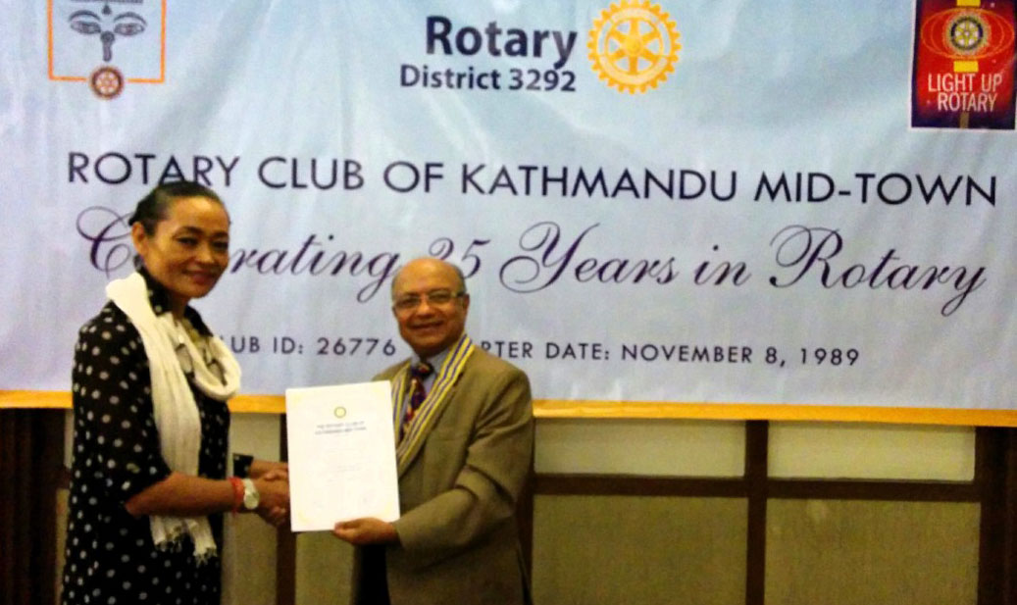

Guest Speaker Sangita Shrestha receiving Letter of Appreciation from President Kul

“Rtn Pabitra introduced the Guest Speaker Ms Sangita

Shrestha. She spoke about Life Style Organic Farming.

“Ms. Sangita spoke in details about the benefit &

importance of organic farming, short term and long term

effects of the use of Pesticides, pesticides residue higher

in nepali population, cocktail spray for quick money making, history of organic farming in Nepal. Most farm organic by default as transportation is not accessible in

many parts of the country. Scope of organic products is

increasing. She also stressed the importance of education

and awareness among people regarding the organic

products. She also said that as a consumer/customer it is

difficult to verify whether the product is organic or not.

“It is the trust factor”.

“Rtn Navyo, Rtn Govinda, Rtn Rabi, PP Mani, Rtn Amar & Mr Sanjib took part in the discussion. PP Devendra gave vote of thanks.”

><><><><><><><><

Information Sharing:

- President Kul thanked PP RR for his contribution for the Breakfast Chatter.

- President Kul highlighted about the Membership Development Seminar held on 16 August. “The highlight of the seminar was to increase the youth and women member in Rotary and the global effort to increase membership”.

- PP CK informed that ANM project is almost coming to an end. Mugu Airport is also open now and that he will try to provide complete schedule in the next meeting.

- Rtn Amar informed about the Fire Brigade Project team arriving from Italy on 25 August.

- Rtn Rabi informed that since next meeting would be a club assembly and induction of new members, all committee chairs to be as brief as possible. He also said that there are other areas besides Sun Koshi. PP William informed that the District is looking for partnership with the right organization for contributing to the flood/landslide victims.

- PP Mani contributed to the Sunshine as his son Abhishek Joshi’s team won Emmy Awards for outstanding visual Effects in Games of thrones (HBO TV Serial).

- PP Mani also informed about the possibility of support of 40,000 Euro for the Spouse Group.

- IPP Saroj gave Token of Appreciation to Daya Foundation (Rtn Neeva) and to Rtn Navyo for his contribution in the Rotary Kite Flying Event.

- President Kul said to address Rtn Govinda’s query he will soon circulate to all members an updated estimated income and expenditure for RCKMT 2014/15 prepared by PP Komal and Treasurer Jo.

- Members present: 25

- Membership paid by 35 out of 50 members

# Weekly Meetings and Prorams :

|  |  |  |
| --- | --- | --- |
| Date | Program/Speaker | Program/Topics of Presentation |
| 29 August | Club assembly | Review and discussion on Club matters/projects |
| 5 September | Craig Sanders, UNHCR Rep |  |
| 12 September | Dr Bekh Bd Thapa |  |
|  |  |  |

**Club Assembly:** Friday, 29 August

The First Club Assembly of the Year will witness a significant event –

induction of 5 new members at a time.

Dr. Shankar Sharma, Mr. Sanjib Raj Bhandari, Ms. Sangita Shrestha Einhaus,

Ms. Sheri Meyerhoffer, and Mr. James Larry Kelly

The Induction ceremony will be administered by PP Mani D Joshi while the Club Assembly will be conducted by AG Rajendra L Shrestha.

**RI President Gary CK Huang’s Ambitious 1.3 mil Membership Goal:**



Gary C.K. Huang never imagined he would become Rotary International's

president when he joined in 1976, but now that he is in office, he hopes to

increase membership to 1.3 million by the end of his term.

"It's simple. The more members we have, the more people we can help.

A stronger membership base will result in stronger communities," says Huang,

who on 1 July became Rotary's first Chinese president.

Huang also hopes his presidential theme, Light Up Rotary, will encourage members to brighten Rotary's image to the public, which he believes in return will improve member recruitment and retention. Huang has a track record of improving membership development in Asia, adding 19 clubs when he was district governor for Taiwan, Hong Kong, and Macau. One of the cornerstones of his presidency is encouraging clubs and districts to conduct a Rotary Day. These one-day events, he says, can spotlight a particular cause, and solidify Rotary's image as one of the world's leading service organizations. "We need to showcase our good work to everyone in the community. Rotary Days need to be fun and all inclusive. Invite your family, friends, and neighbors to participate. My hope is at the end of the day a few non-members will want to join Rotary," he says. "Let's give people the opportunity to experience what it's like to make a difference. Rotary Days can achieve that." Huang designed a travel schedule that will allow him to visit more than 30 Rotary Day events across the globe, including Argentina, Chile, France, India, Italy, Korea, Malaysia, Philippines, and the U.S., as well as his home city of Taipei.

Huang says he's honored and humbled to be Rotary's president. He knows he's part of an exclusive club. "We [past Rotary presidents] have achieved great success in our businesses and in our communities," says Huang. "But success isn't about power or money. It's about giving back. Being a Rotarian has given me the opportunity to help those in need. As president, I can inspire our members to take advantage of the same opportunity and bring happiness in people's lives."

*- Ryan Hyland / RI News*

**RI President 2016-17:**

**John Germ, choice of Nominating Committee for 2016-17 RI President**

John F Germ, a member of the Rotary Club of Chattanooga, Tennessee, USA, and Chair of the International PolioPlus Committee, is the selection of the Nominating Committee for President of RI in 2016-17. He will become the President-Nominee on 1 October this year if there are no challenging candidates.

-  *Rotary International News*

**Gokarna Aunsi/Kuse Aunsi**: 25 August

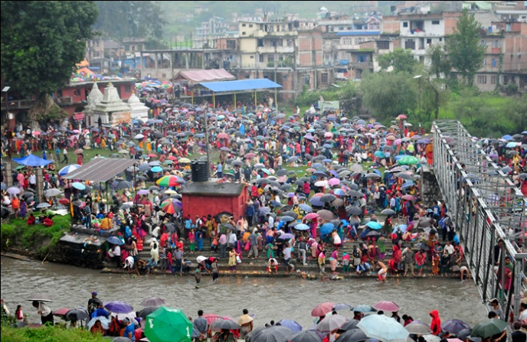

*Kushe Aunsi* or *Gokarna Aunsi* was observed by Hindus

across the globe, on Monday.

Brahmin priests store the holy *‘kush’* in the prayer-rooms

of Hindu households, enough for a year of holy

ceremonies, on this day. On this day, also known as

the *'buwa ko mukh herne din'*, children show their

respect and pay gratitude to their fathers by giving

them gifts and preparing delicacies for them.

Hundreds of devotees throng the Shiva temple in

Gokarna, and take a dip in the holy Bagmati River

on this day.

People perform ‘*shraadha*’for their deceased fathers at different river banks on this day.

The bond between fathers and the children are celebrated on this day.

Nepal has more than 70 ethnic groups with almost all have their own tradition and languages. The people of different communities and tribe have their own way of celebrating father’s day. Some communities celebrate it empty stomach early in the morning and some communities celebrate it in the evening.

However, all the communities prepare foods and tasty feast in and serve it to their fathers. The celebration and fun of the festival depends upon the place, climate and ethnicity.

><><><><><><><><

**Teej and Rishi Panchami :** 27 – 30 August

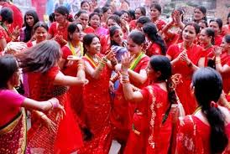

Teej is celebrated by the women of Nepal and some part of India with

lots of joy and enthusiasm. Most married women rich or poor observe

this festival with fun. Teej is observed for marital happiness, well-being

of spouse and children and purification of own body and soul.

It is a three-day-long celebration that combines splendid feasts as well

as rigid fasting. Women who go on fasting the next day eat a big feast -

*daroh khana,* that means, a heavy or a big feast, now it’s called

‘dar-khane’ - with a variety of nice food items, sweet items and what

have you; it varies in communities.

The first day of Teej is called *Dar Khane Din*. On this day all the family members especially the women, both married and unmarried gather at one place, in their finest outfits of red and start dancing and singing devotional songs mixed with Nepali folk and Dohori songs. The fun often goes untill midnight, after midnight the 24-hour fasting starts.

Second day is the main day of Teej (the fasting day). Some women take it very rigid, they do not even drink a drop of water while some others take liquid and fruit. On this day, they happily dress in red and visit a nearby Lord Shiva’s temple singing and dancing all the way. Most of devotees in Kathmandu go to Pashupatinath Temple. Though the women fast throughout the day - refusing to take even a drop of water - Teej brings smiles on the faces of women in the cities and villages. The most important part of the pooja is mostly done in the evening burning the oil lamp which should be burning throughout the night

Third day women get up early in the dawn and get cleaned and do the puja once again to the diyo and goddess Parvati. The most important part of this puja is a banana and holy basil (Tulsi patta) leaf. Only after this puja, women take their regular food. This third day of Teej is Ganesh Chaturthati

Rishi Panchami, the fourth day of the Teej, women pay homage to various deities and bathe with red mud found on the roots of the sacred Datiwan plant, along with its leaves. This act of purification is the final ritual of Teej, after which women are considered forgiven from all their sins. The recent years have witnessed an adjustment in the rituals, especially regarding the strictness, but its spirit remains the same.

*Source:* Internet News

**Turtles Talking:**

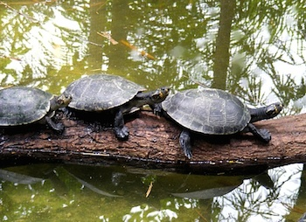

Have you heard turtles talking?

Obviously not. But scientists in Brazil do!

River turtles have been heard ‘talking’ to one another by scientists in Brazil.

The experts recorded the turtles and found that they exchange information

vocally using at least six different sounds. Chatter between females and her

newborn hatchlings was recorded too. The researchers say this is the first

record of parental care in turtles. It means turtles may be more social than

we initially thought. The meanings aren’t clear but it is thought that they

exchanging information.

*Source:* Internet News

On Lighter Side :





Great Quotes:

**Throughout life people will make you mad, disrespect you and treat you bad.**

**Let God deal with the things they do,**

**cause hate in your heart will consume you too.**

***- Will Smith***



In order to keep serving, Rotary always needs to be growing!

**RI President GARY C.K. HUANG**

Please send information on club activities, progress reviews on service projects, relevant photos etc to:

BC Editor: RR Shrestha email: rryesrr@gmail.com

## 29 August 2014 The Weekly Bulletin of Rotary Club of Kathmandu Mid-Town bc-09/8.014